Matthew Strauss

GWS

Professor Policoff

12/19/17

**Going Through Time in Times Square**

Going on spontaneous adventures has always been a pastime of mine, and “The City That Never Sleeps” is a perfect place to explore on a rainy Thursday night. The dreary night sky was lit up by the thousands of lights permeating from one central location, Times Square. Seeking out some excitement, my friends and I, bored after catching a later dinner after a long day of classes, decided to head into the perceived heart of New York. It was only a short subway ride away from Washington Square Park, but waiting in the subway station made a chilly October night feel like a dreadful summer day. Upon finally arriving at Times Square, we were met with herds of tourists, street vendors peddling their goods, and policemen steadily manning their post. It was not my first time, or even 2nd or 3rd time in Times Square, but something about tonight felt different.

The bustling atmosphere of a Friday night compounded with the piercing bright lights of the advertisement billboards contrasted the gloomy weather and created an intriguing and mystical atmosphere. My friends, being the dutiful photographers they are, decided on an impromptu photo shoot, tasking me with standing on the concrete NYPD barrier and striking a pose. Initially, I felt awkward and out of place posing in the middle of the busiest part of the city, but I quickly came to the realization that nobody, tourist or New Yorker, cared. This city is far too hectic for anyone to be concerned with anything other than their own problems. Later we sat down at a 24 hour McDonalds saturated with tourists and began to engage in wholehearted conversations that lasted hours, long after we devoured our 10 piece McNugget meal as we waited on a few more friends to make the 40 block trek up from NYU to join us.

This photo representative of blossoming friendship, late night adventures, and the beating heart of the city, one I feel as if I am becoming more part of everyday. Sontag states that, “Life is not about significant details, illuminated a flash, fixed forever. Photographs are.” (Sontag, 81). While living in the moment is important, our lives, and my life in particular, are not a constant photoshoots and highlights of our most important moments. In all honesty, when I look back on that night I went to Times Square in 10 years, I will probably forget most of what had happened, but immediately after seeing the photograph, my mind would no longer have to piece together the formerly incongruent memories, the photograph will allow for a nostalgic recollection that no other art form can. In the photo, I can be seen overlooking the bright lights of Times Square in awe, albeit in a confident pose. I feel this can represent my growing maturity and adaptation to the Big Apple. I have only been here 3 months, but I have experienced an extraordinary amount of profound experiences that I feel as if I can comfortably proclaim I am an unconditionally different person than I was when I left California for college in August. Initially, I had doubts if I would be able to handle the transition to this bustling, at times overwhelming, city, but so far it has gone without a hitch, making me excited for the prospect of the future here. Any prior concern or uncertainty to how I would adjust, how I would fit in, has completely dissipated. Furthermore, upon arriving in Manhattan, I did not know anyone. I had some worries about making friends as I am an introverted person by nature, I had heard through miscellaneous internet research that it is easy to become isolated at NYU, and New York in general. Luckily, I never experienced this isolation. I met an intimate group of friends the first week of school with whom I attribute helping ease my transition into college and adjustment to New York. All my friends hail from different places geographically, from the rural forests of the Northeast, to the sandy beaches of Santa Barbara. We are all experiencing this journey of discovery together, both of ourselves and the city. Exploring this concrete jungle simultaneously in unison has allowed us to grow closer. You don’t go surveying the city at 2 am with people you don’t trust. I feel as if these late night, spontaneous adventures with my friends have allowed our relationships to flourish. I have allowed myself to grow closer to these people, more than I ever did to others in any phase of my life. Whether it is because of the inspiration of the city, or an expedited maturation of myself, I do not know, but whatever the reason, I am thankful for having these people in my lives, and could have never anticipated the trajectory my life has taken since coming here. Had I gone to a different school, one closer to home, I have no doubts that I would be a significantly different person, and my life would subsequently be remarkably different as well. Right now I am living my best life imaginable, and I could not wish for, or imagine anything more. These are people who I can envision being lifelong friends, far after college ends, far after our journeys take us in different directions.

A particular aspect of this photo I find intriguing is the LED American flag billboard located right in the middle of the picture. It represents the resilience of the city, a city which has seen its fair share of tragedy both recently and years in the past, but always perseveres no matter what. The city’s resolve serves as an inspiration in my personal odyssey, teaching me that no matter what obstacles life throws in my way, I will be able to flow around it, just as the Hudson flows into the Atlantic. Additionally, the color palette of red, white and blue is harmonious throughout the photo, even matching my flannel shirt.

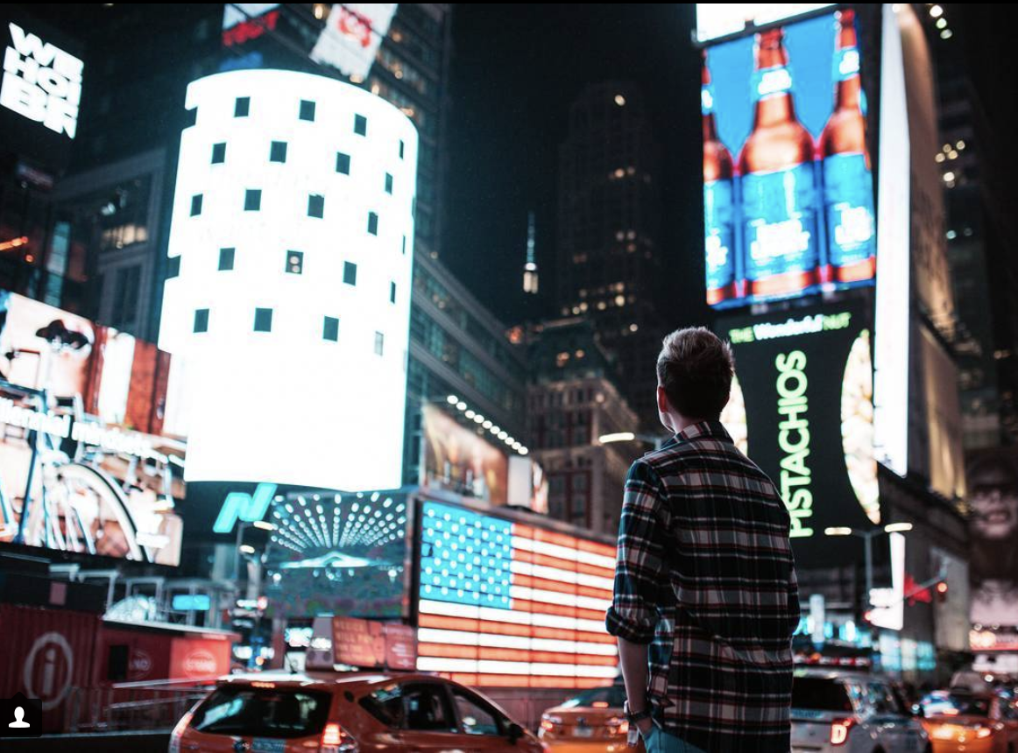

While looking through historic pictures to choose for this project, Alfred Eisenstaedt’s iconic *V-J Day in Times Square* photograph immediately came to mind due to its similar location, contrasting nature in comparison to my personal picture, and its illustrious reputation. The photo was taken on August 14th, 1945 in Times Square, just one hour prior to President Truman’s official announcement that the war with Japan had ended. In the photo, a Navy sailor can be seen joyfully embracing and kissing a nurse in a white uniform, much to the jubilation of the observers passing by in the background. The bystanders are within focus, despite not being the main subject of the photo. The picture, shot on a Leica IIIa is in black and white, showing the antiquity of the photo, was shot long before cellphones were the primary means of photography, and Times Square was inundated with LED advertisements. The sailor represents the return of the men who had gone overseas to fight, with the nurse representing the women who welcomed them home. Home being Times Square, the heart of New York City, the heart of the country. In a broader context, the photo represents the unity of the country through a time of difficulty and immense struggle. During World War II, the country came together in a way never seen before in support of the war effort. Every citizen did their part to keep the nation afloat and prosperous, like a cog in a wheel. The kiss represents the pent up emotions of fear and anxiety finally being extinguished and free to let loose after years of confinement. The years of lives being put on hold to focus on the global massacre had ended, the country could start anew, a rebirth was in action, Americans were finally free to live their lives in peace. Furthermore, it was an act of spontaneity, as Eisenstaedt detailed “I saw a sailor running along the street grabbing any and every girl in sight. Whether she was a grandmother, stout, thin, old, didn't make a difference.” An act of pure joy and elation representing the celebration of freedom the end of the war constituted.

The darkness of the sailor’s presumably navy blue uniform in comparison with the nurse’s all white ensemble, only his hat matching her outfit, provides a stark and stunning contrast that adds extra emphasis to the subjects in the picture, a contrast Eisenstaedt immediately recognized and rushed over to capture. It seems that in this photo, the two are in their own world, despite being in one of the busiest intersections in the universe. The slight sense of discomfort in the pose of the nurse seems to indicate that she was blindsided by the kiss. The photo gives off a hedonistic feeling, as if the soldier took advantage of the occasion to act in a sybaritic manner without facing repercussions. The photo also represents the importance of timing and seizing opportunities. Had Eisenstaedt been a second later, it is possible that this iconic photo would have never been shot.

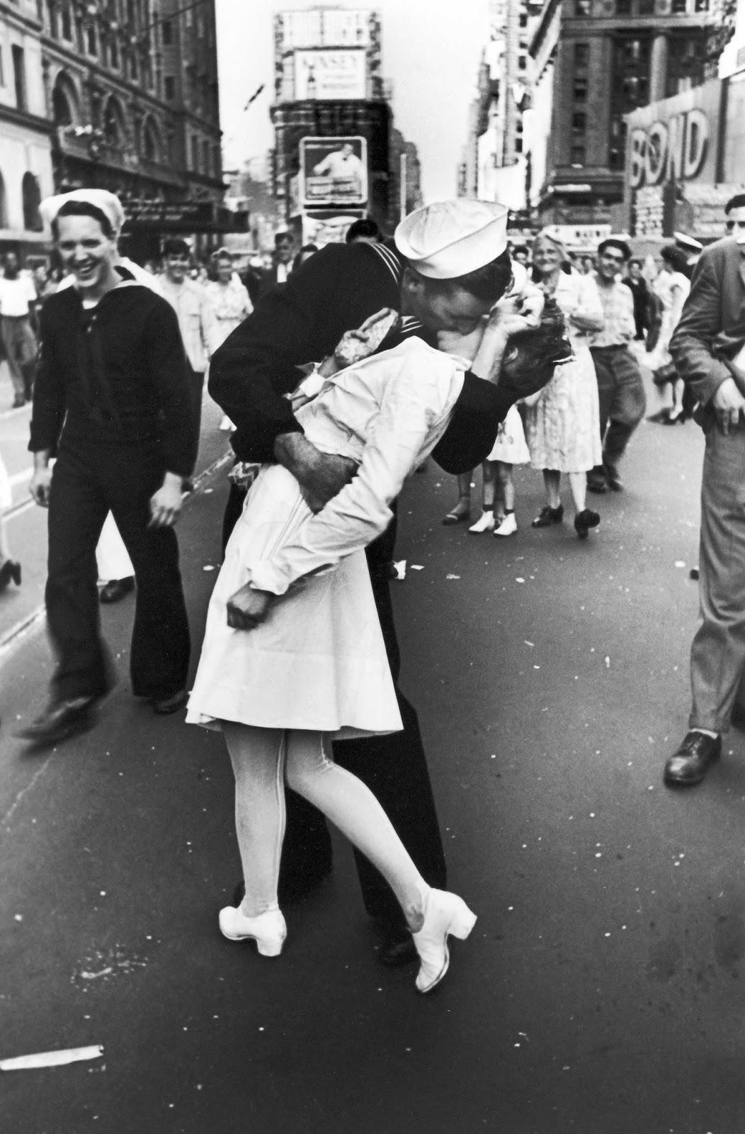

These two photos resonated with me in a compelling matter, due to the commonality in their location, and contrasting tones. While these photos are similar in location, they tell a different story of New York, and a different story of the subjects. In the case of the iconic photo, the celebration of finality and ushering in a new era after the war and with my personal picture, the celebration of the start of a new life. My personal picture is one I am distinctly proud of (my friend, the photographer is too, he even added it to his portfolio), and the iconic photo has always been a favorite of mine given my interest in post war art, so the to connect them felt natural. Both photos were shot in Times Square, my personal photo being taken on 7th Ave, a few meters before the 43rd Street intersection, while the historic *V-J Day in Times Square* photo was shot on 45th Street, right before the 7th Ave and Broadway intersection. The location is just the preface of numerous different similarities within the two photos. They both represent a new beginning, my photo representing the genesis of my new life in New York, and the V-J Day photo representing America’s new, post war life, an interjection of new found spirit. Additionally, these photos can be viewed through their contrast of new versus old. These two photos give the viewer a glimpse through time. Sontag writes, “The past itself, as historical change continues to accelerate, has become the most surreal of subjects—making it possible…to see a new beauty in what is vanishing. From the start, photographers not only set themselves the task of recording a disappearing world but were so employed by those hastening its disappearance.” (Sontag, 76). There is beauty in observing what once was, whether it be due to a nostalgic reaction, or just appreciation of the lack of finality of what is being observed. Much of what I saw in Times Square was not there in the 1945 V-J Day picture, and much of what I observed will not be there 72 years from now. It gives the viewer a new found appreciation of how in that specific moment, time stood still, a phenomena which can be attributed to photography. No shiny new LED billboards were being installed, no monolithic skyscrapers were being constructed, the hustle of the city adjourned in a single moment to be captured and treasured.

When I look at the V-J Day photo, I see a sense of unity and community that is uncommon in today’s America. We are currently at a time where our country is the most divided it has been in centuries. A division of politics, a division of classes, a division of people. Perhaps that modern lack of spirit and division are just a byproduct of the growth of the nation and the world. Although things were far from perfect in 1945, the V-J Day photo highlights a time of coming together, a time of celebration, a time of jubilation and appreciation of our country’s persistence. However, it also fails to represent a country that was still extremely hindered by a lack of basic human rights, taking place in an era prior to Civil Rights. While many were in the streets celebrating victory and freedom, many of their fellow citizens still lacked it. In that respect, the photo paints a false portrait of the mood of the country at the time. This can especially be noted by the homogeneity of the people in the photo. Nowadays, you can go to Times Square and hear 10 different languages spoken by people from 5 different continents. Times Square has become the premier tourist attraction of New York, but that is all it is treated as, a spectacle. Businesses use the area as a gigantic advertisement for their new products, opportunists use it as a place to take advantage and make a quick buck. How will this area look when I gaze upon my old photo, reminiscing? What will its identity be then? Photographs give power to allow timeless reflection, a rarity in the never changing constant which is life. The subjects in the photo will die, the buildings will perish, the memories may fade, but the photo lives on.

Works Cited

Sontag, Susan. *On Photography*. Allen Lane, 1978.

“V-J Day Kiss in Times Square, 1945.” *Rare Historical Photos*, 7 Oct. 2016, rarehistoricalphotos.com/v-j-day-kiss-times-square-1945/.